Software requirements specifications

(SRS) Document

Online Hand Cricket Game

Under the guidance of dr. A. venugopal

Vardhan Karanam - 19N81A05B0

Sree Uday - 19N81A0592

 G. Sreekar - 19N81A05B5

Sphoorthy engineering college(2022)

**Revision**

| Version | Primary Authors | Description of Version | Date completed |
| --- | --- | --- | --- |
| **1** | G Sreekar | Version 1 |  |
|  | P Sree Uday |  |  |
|  | K Srivardhan |  |  |
|  |  |  |  |

## 

## Review and Approval

**Requirements document approval history**

| Approval party  (Guide name) | Version approved | Signature | Date |
| --- | --- | --- | --- |
|  |  |  |  |
|  |  |  |  |

**Requirements document review history**

| Reviewer  (Guide name and other staff names who reviewed it) | Version reviewed | Signature | Date |
| --- | --- | --- | --- |
|  |  |  |  |
|  |  |  |  |
|  |  |  |  |

## 

## CONTENTS

1.Introduction…………………………………………………4

2.General Description………………………………………….5

3.Functional Requirements…………………………………….7

4.Other non-functional attributes………………………………7

4.1 Security………………………………………………….7

4.2 Binary Compatibility ……………………………………7

4.3 Reliability ……………………………………………….8

4.4 Maintainability…………………………………………..8

4.5 Portability………………………………………………..8

4.6 Extensibility……………………………………………...8

4.7 Reusability………………………………………………..8

5. Operational Scenarios………………………………………….8

6.Updated Schedule……………………………………………….9

7. Appendices……………………………………………………10

7.1 Definitions , Acronyms, Abbreviations …………………10

7.2 Plagiarism Report……………………………………….11

## 1.Introduction

**1.1 Introduction**

This is a web related system the main requirement of Technology for this are multiple programming Environments and languages such as JavaScript, Java Server Pages, HTML, .NET, CSS , Node environment. For storing and retrieving data there is a requirement Of database which MySQL is used.

Thefunctionality of the system is a simple web based game which takes two players to function .The main goal of the system is to let a new kind of cricket themed game reach with the simplest measures it works with numbers between one and six .The system allows player to choose between odd number or even number then both players select a number in the specified range of system the system displays the numbers and sums them up based upon their choice if the resultant is odd then the player whose choice was odd will be given the opportunity to bat/bowl and vice-versa , the player who is batting first selects a number within range where the system gives a user friendly buttons to select the appropriate number of user’s choice on the other hand the player who get’s to bowl tries to guess what the batting player’s choice was, if the bowler successfully guess the number which batsmen chose then a wicket will be down if not then the number batsmen chose that will be added to his score card the system evaluates all these and provide user a very friendly and systematic experience after ten wickets have fallen then the batting side’s total score plus one will be given which will be the target for the bowler now who become the batting side and the batting side now gets to bowl and tries to eliminate the batting side by picking up all wickets (ten) before they reach the target score , Constraints involved are this is only for two players not more, and does not include much graphic work like other games.

**1.2 Scope of this document and project**

This document minimises the time and effort for those who are new to the system engineering and also minimises the development cost , this also clearly specifies how the system interact with Hardware and software components.

The project works with minimal assistance and requirements with a fun-filled output which encourages everyone to use it , this project takes minimum time to get completed with almost no budget needed , the way it is designed Anyone can understand it’s simple fundamentals , a good user friendliness is The main motive of this project.

**1.3 Overview**

1. Allow two players to join on same server

2. A proper calculation of choices of two numbers between the players is needed

3. Based upon the result appropriate designations should be allotted to the players

4.Batting side’s score should be carried without any mistakes and should be reflected right after

5. Response of the system should be quick enough

6. User friendliness must be extremely good

7. There shouldn't be any delay between system functions

**1.4 Business Context**

As there are no other web-apps or applications on this theme a new , unique themed game willattract many people to come and try which can make this into profits with its unique setup andfeatures.

Every feature in this is completely free with no additional in-game charges making more commonpeople to use and experience a never seen before kind of atmosphere.

User friendliness will be taken care at almost quality which makes the user to feel good and easeallowing them to experience the richness of game flavour , the system will be designed such thatthere won’t be any crashes or bugs so that the user can spend their time at a good quality.

## 2. General Description

**2.1 Product Functions**

The product serve to deliver the simple and a new kind of cricket game experience where the user friendly atmosphere is the main motive and other features like usability , dependability , and other software metrics are taken care with at most preference

**2.2 Similar System Information**

1.match is guided with the help of human match referee

2. In this system the role is much hard , it may create inaccuracy

3. The bowling and batting are done one by one

**2.3 User Characteristics**

Two users one is a batting side user and other will be a bowling side user the batting side user tries to chose a number that bowling side user don’t and try to score as many runs he could , while the bowling side user tries to guess the batting side user’s number

**2.4 User Problem Statement**

We try to enable user friendliness as much as we can to the user the most kind of problems to users with gaming web-apps are the system behaviour , user interface , complications we try to eliminate all these to the users playing our web game

**2.5 User Objectives**

The objectives of the user are quite simple as all they need to do is select a number either to score runs or to take a wicket

**2.6 General Constraints**

JavaScript : for dynamic nature of client side

Java Server Pages : for server side programming

HTML : for the basic layout of website

CSS : for design and attraction of website

.NET : for user friendliness and hosting

Node environment : for server side scripting

mySQL : for relational database management

Amazon Web services : for system maintenance and server maintenance

## 3. Functional Requirements

**Batting -side user :**

1. Simultaneous action between both sides :

The user expects the bowler number to reveal at same time so that he can play accordingly with the bowler’s mindset.

1. Proper score management :

As every run matters in these kind of games the user expects for the system’scalculation to be appropriate

**Bowling-side user :**

1. Exact target is set :

The system must make sure that correct target is set so that the user can come with a mindset of chase

1. User friendly chase :

The system should help the chasing side by showing different ways of winBy run-rate calculations

1. Proper wicket management :

As every wicket matters in these kind of games the user expects for the system’s response to appropriate

## 

## 4.Other non-functional attributes

**4.1 Security**

The system is designed with a high level of security by making sure that all information is enclosed within the boundaries , and no sensitive information is asked from theclient end, the password of database is encrypted to the at-most level making surethat the system never generates anything outside its parameters , the design of databaseis established through functional dependency which makes the leak of data highly difficult client’s safety and trust of information is one of the System’s main objective

**4.2 Binary Compatibility**

The system will be compatible with any computer that has JavaScript enabled and cookies turned on (pc / Mac / linux / unix ) , It is designed with more than one computer / OS in mind

**4.3 Reliability**

Reliability is one of the key attributes of the system Back-ups will be maderegularly so that restoration with minimal data loss is possible in the event of unforeseen events. The system will be thoroughly tested by all team members to ensure reliability.

**4.4 Maintainability**

The system will be constantly maintained by the entire team making sure thaeverything functions in its designed manner also In the later stages some admin precautions will be taken to maintain.

**4.5 Portability**

The system will run with any computer that has javascript enabled , it can be run at any number of systems at a time.

**4.6 Extensibility**

Anyone who understand the basic rules of the game which we provide in helpsection can understand how to play and access the system , we provide additionalinstructional support from our team personally anytime if needed.

**4.7 Reusability**

The system is designed in such way that the database is re-used for storing the information and at a time the same website interface is re-used.

## 5. Operational Scenario

**Scenario A : Starting the system**

The system start with a introduction and follows up with a main menu pagewhere the user can select which mode of game he/she wish to play variousoptions would be provided in the main menu depending upon the choice of user the system directs into that gameplay option.

**Scenario B : Gameplay in the system**

The game starts with a toss to decide who bats and bowls then the gameplay starts with a simple user interface.

**Scenario C : Storing of data**

The system stores the data of user related to game like his username, high-scoreto enable a option for the user to look at his stats , during the gameplay phase and registration phase the data will be stored in the database.

**6. Updated** **Schedule**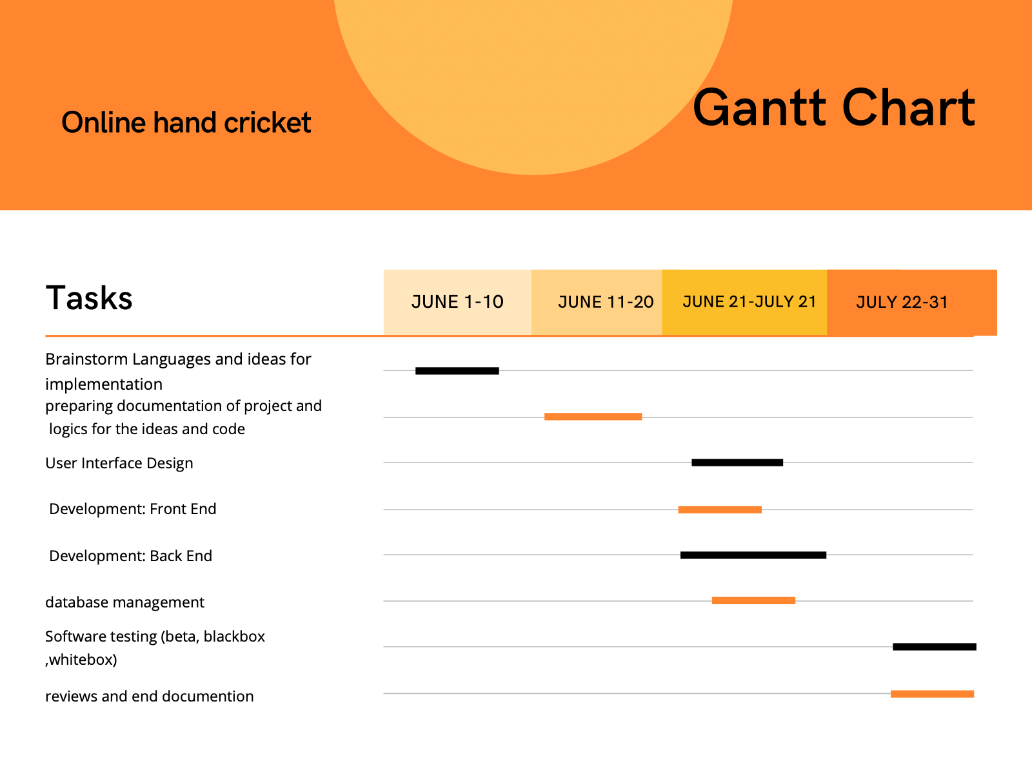

## 7. Appendices

**7.1 Definitions, Acronyms , Abbreviations**

MySQL : my Structured Query Language.

CSS : Cascading Style Sheets.

.NET : Dot Network enabled technologies.

HTML : Hyper Text Markup Language.

**7.2 Plagiarism Report**

